Doom (1993, PC), id Software. GAMEPLAY MODE

1. Composition
Tangible space | Tangible space occupies the overwhelming majority of the screen.
Intangible space | Useful data is overlaid on some rock-textured ornemental negative space.
Negative Space | Occupies a band at the bottom of the screen.
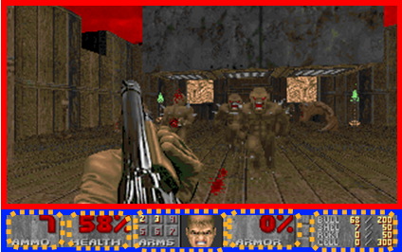
Internal | Primary
2. Ocularization

3. Framing mechanisms | Anchor : Subjective | Mobility : Connected

4. Plane Analysis
 | Agents | In-game | Off-game
Graphical materials | Raster | Real-time 3D | Real-time 3D
Projection method | Orthogonal | Linear | Linear
Angle of projection | Horizontal | First-Person | First-Person

Notes:
Doom’s pioneering first-steps into the first-person shooter is a very impressive technical feat for the time.
Doom also puts forward the experience of the gaze in a strongly mimetic way, simulating the characters’ steps through animation and offering a thoroughly textured environment. A connected mobility seldom had given access to such a powerful sensation of walking around in a digital environment. Of course, this has become a major standard of high production value since, but at the time it was quite a hack.

